The characteristics of EEG for drowsiness

* Drowsiness is characterized by EEG changes of
  + gradual or rapid ‘alpha’ dropout (<50% of epoch contains ‘alpha’ frequencies)
  + with ‘theta’-range rhythms (from 4.5-7.5 Hz) appearing
  + and can be mixed with very low-voltage faster (15-Hz to 25-Hz) activity [1, 2].
* Deepening of drowsiness is characterized by increasing slow activity with transients of 2 to 4 Hz and 4.5 to 7 Hz. There are vertex sharp waves, which can appear as an isolated event or can occur in trains of events, slow-rolling eye movements, and moderately increased muscle tone [1].

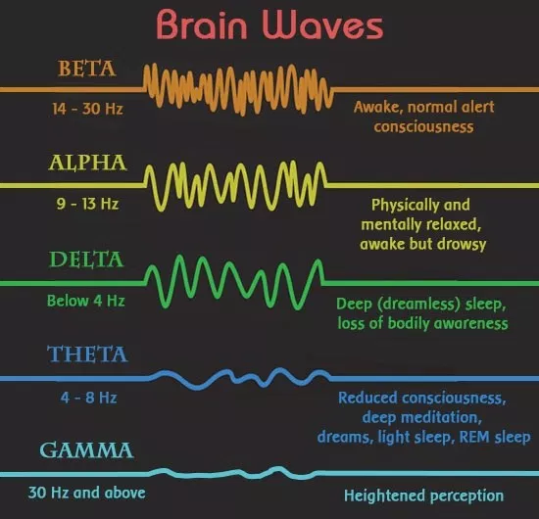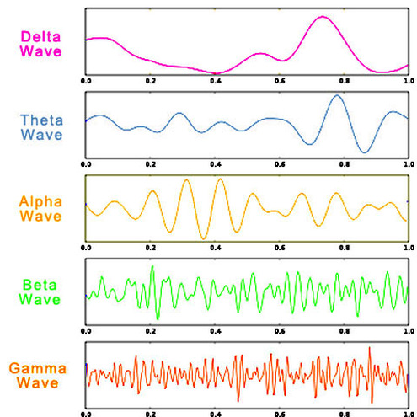

EEG features

1. Based on [1], [9]
   1. Basic data: EEG power of
   2. The relative power of each frequency band X



* 1. The rate of change for the relative power:

1. Based on [4], [6]
   1. Mean value
      1. , where x is EEG signal and N is total number EEG data

*→ What type of EEG signal we use depends on us.* (not specific)

* 1. Standard deviation

*→ What type of EEG signal we use depends on us.* (not specific)

→ The mean and the standard deviation are considered appropriate measures for a time series with symmetric distribution.

* 1. Skewness: It is the degree of distortion from the symmetrical normal distribution. It measures the lack of symmetry in data distribution.

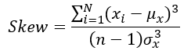

* + - 1. : *What type of EEG signal we use depends on us*
      2. : the mean of all x
      3. : the variance of all x
    1. **Positive skewness** means when the tail on the right side of the distribution is longer or fatter. The mean and median will be greater than the mode.
    2. **Negative skewness** is when the tail of the left side of the distribution is longer or fatter than the tail on the right side. The mean and median will be less than the mode.
    3. If the skewness is between -0.5 and 0.5, the data are fairly symmetrical.
    4. If the skewness is between -1 and -0.5 or between 0.5 and 1, the data are moderately skewed.
    5. If the skewness is less than -1 or greater than 1, the data are highly skewed.

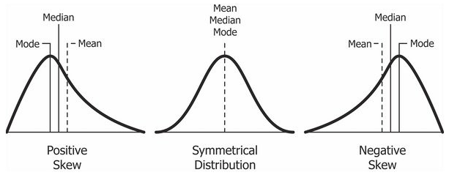

* 1. Kurtosis: It is the measure of outliers present in the distribution.

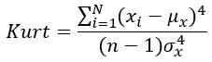

* + - 1. : *What type of EEG signal we use depends on us*
      2. : the mean of all x
      3. : the variance of all x
    1. **High kurtosis** in a data set is an indicator that data has heavy tails or outliers. If there is a high kurtosis, then, we need to investigate why do we have so many outliers.
    2. **Low kurtosis** in a data set is an indicator that data has light tails or lack of outliers. If we get low kurtosis(too good to be true), then also we need to investigate and trim the dataset of unwanted results.
    3. **Mesokurtic**: This distribution has kurtosis statistic similar to that of the normal distribution. It means that the extreme values of the distribution are similar to that of a normal distribution characteristic. This definition is used so that the standard normal distribution has a kurtosis of three.
    4. **Leptokurtic (Kurtosis > 3)**: Distribution is longer, tails are fatter. Peak is higher and sharper than Mesokurtic, which means that data are heavy-tailed or profusion of outliers.
    5. **Platykurtic: (Kurtosis < 3)**: Distribution is shorter, tails are thinner than the normal distribution. The peak is lower and broader than Mesokurtic, which means that data are light-tailed or lack of outliers.

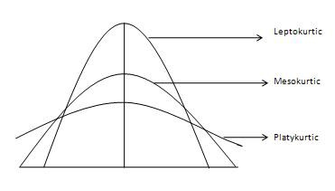

* 1. Others: median, maximum, minimum, mode, range, first quartile, second quartile, variation from [6]
     1. A skewed distribution median, range, and quartile are effective to measure the center and the spread of a dataset
     2. Maximum, minimum, variation, skewness, and kurtosis are used as measures to pull out the important information about a time series.

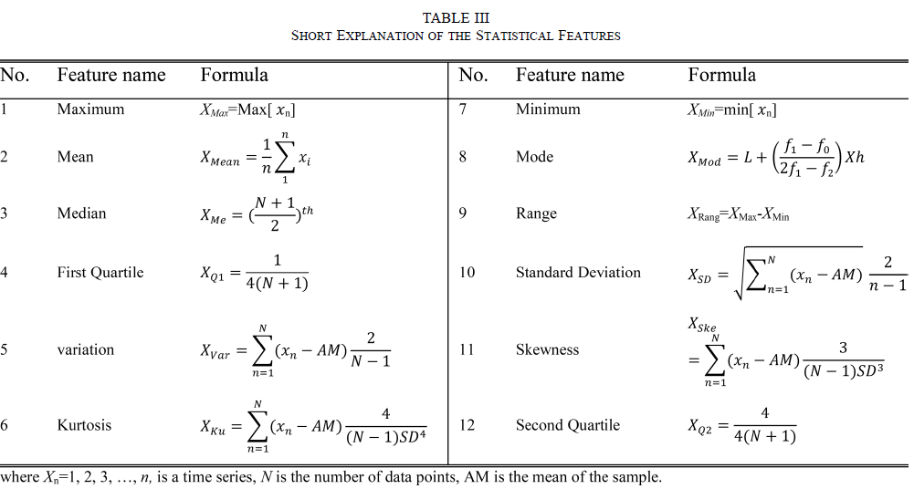

1. Based on [7]: 10-s EEG epoch

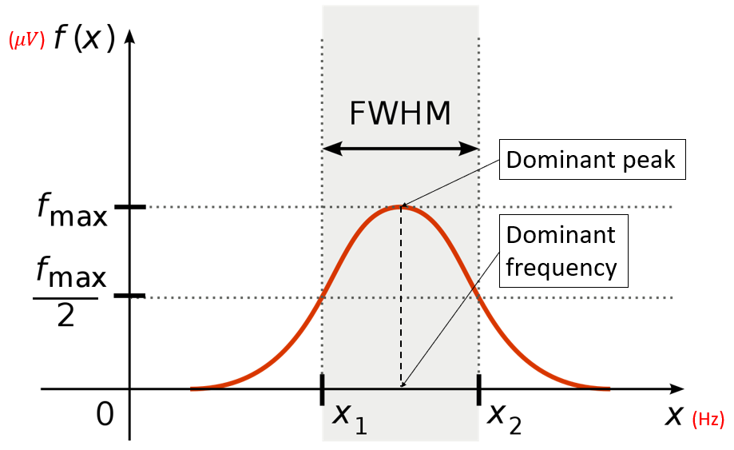

* 1. Dominant frequency
     1. This feature is to capture the dominant peak with the most significant bandwidth within a considered frequency band.
  2. The average power of the dominant peak
     1. This was defined as the average power on the full width half maximum band of a dominant peak.
     2. It represents the significance of the dominant peak.
  3. Center of gravity frequency (CGF)

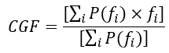

, where f is frequency and P(f_i) is the estimated power spectral density.

* + 1. If the spectrum for a considered frequency band is dominated by two narrow peaks, it is not difficult to see from CGF equation that the center of gravity frequency will fall in between these two peaks, whereas the dominant frequency will be the frequency of the largest peak.
  1. Frequency variability (FV)

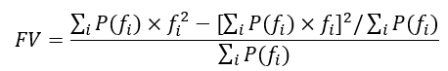

* + 1. This feature is the variance of the frequency in the defined frequency band.

1. Based on [8]: Index (a) showed a larger increase. The results have implications for detecting fatigue.
   1. [9]

* All four showed an increase in the ratio of the slow wave to fast wave EEG activities over time.
* showed a larger increase. The results have implications for detecting fatigue.

1. Based on [10]
   1. Relative power spectral density value for each 1 Hz bin from 1 Hz to 40 Hz

* **Why?** *to select proper features among them*

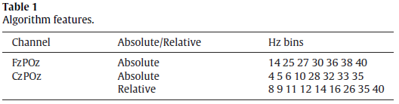

* **Result?**

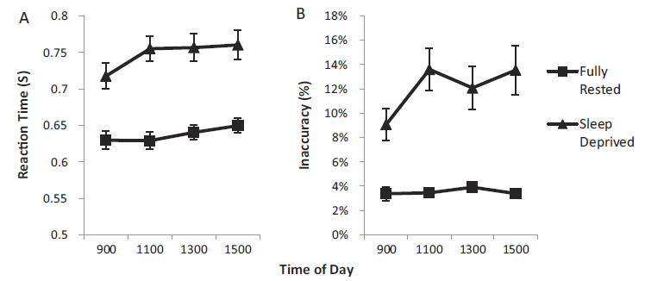

**[If we use wavelet transform, I’ll check it more deeply for No. 6 and No. 7.]**

1. Based on [11]: Features extracted from high-frequency bands are more stable than features extracted from the low-frequency bands. FFT is not very suitable to extract features localized simultaneously in the time and frequency domains. **The features extracted by FFT are of global nature either in time or frequency domains so that the interpretation of the results may not be straightforward**. FFT is more suitable for analyzing stationary signals, while physiological signals like the EEG, tend to be nonstationary ones. The **wavelet transform** is more suitable than FFT when dealing with nonstationary signals. Kernel-feature-projection techniques were necessary to provide an average accuracy of 91%.
   1. Employ the **wavelet packet transform (WPT)** to construct features that highly correlate with alertness and the different levels of drowsiness. The WPT can deal with abrupt changes, spikes, drifts, and trends. The WPT may be thought of as a tree of subspaces.
      1. Feature construction
      2. Bases selection (given an ensemble of bases)
2. Based on [12]: implemented **the wavelet decomposition** to extract the nonlinear features with different time and frequency scales.
   1. Approximate entropy (ApEn)
   2. Sample entropy (SampEn)
   3. Renyi entropy (RenEn)
   4. Recurrence quantification analysis (RQA)

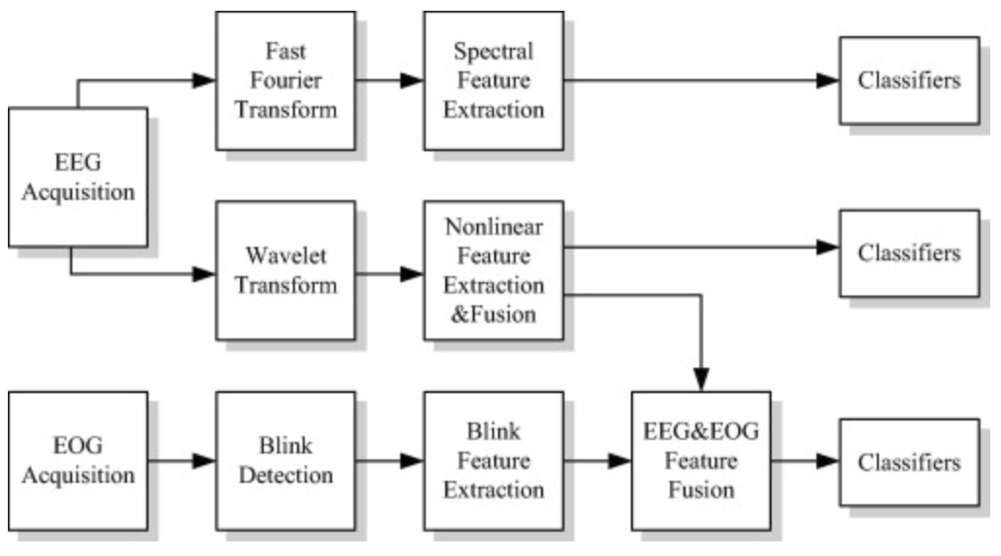

Classification using EEG features

1. EEG features are training to support vector machine (SVM), k-nearest neighbor (kNN), and artificial neural network (ANN) classifier separately for performance analysis of proposed framework [4, 5].
2. Based on [6]
   1. Artificial neural network (ANN) models
      1. Multi-layer perceptron neural networks (MLPNN)
      2. Mixtures of experts and EM algorithm
3. Based on [12]
   1. Extreme learning machine (ELM) cannot only avoid falling into local optima but also largely improve the learning speed.
      1. Wavelet-based nonlinear features were fed to the ELM classifier
         1. Basic ELM with sigmoid activation function (non-kernal case)
         2. ELM with Radial Basis Function (RBF) network (kernel case)

Reference

[1] Swick, “The Neurology of Sleep: 2012 (2012)”

[2] <https://www.medicine.mcgill.ca/physio/vlab/biomed_signals/eeg_n.htm>

[3] Louis et al. “Electroencephalography (EEG): An Introductory Text and Atlas of Normal and Abnormal Findings in Adults, Children, and Infants (2016)”

[4] Islam et al. “Feature extraction and classification of EEG signal for different brain control machine (2016)”

[5] Amin et al. “Feature extraction and classification for EEG signals using wavelet transform and machine learning techniques (2015)”

[6] Diykh et al. “EEG Sleep Stages Classification Based on Time Domain Features and Structural Graph Similarity (2016)”

[7] Mervyn et al. “Can SVM be used for automatic EEG detection of drowsiness during car driving? (2009)”

[8] Thomas et al. “Using EEG spectral components to assess algorithms for detecting fatigue (2009)”

[9] Eoh et al. “Electroencephalographic study of drowsiness in simulated driving with sleep deprivation (2004)”

[10] Johnson et al. “Drowsiness/alertness algorithm development and validation using synchronized EEG and cognitive performance to individualize a generalized model (2011)”

[11] Khushaba et al. “Driver Drowsiness Classification Using Fuzzy Wavelet-Packet-Based Feature-Extraction Algorithm (2011)”

[12] Chen et al. “Automatic detection of alertness/drowsiness from physiological signals using wavelet-based nonlinear features and machine learning (2015)”